Task 1

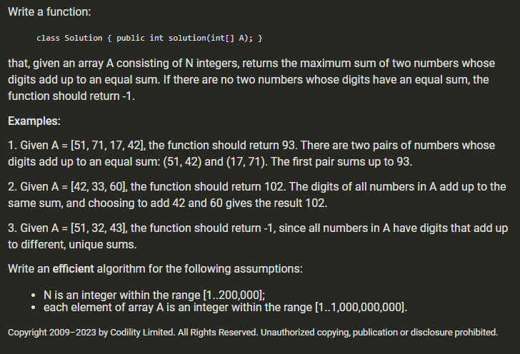

Task 2

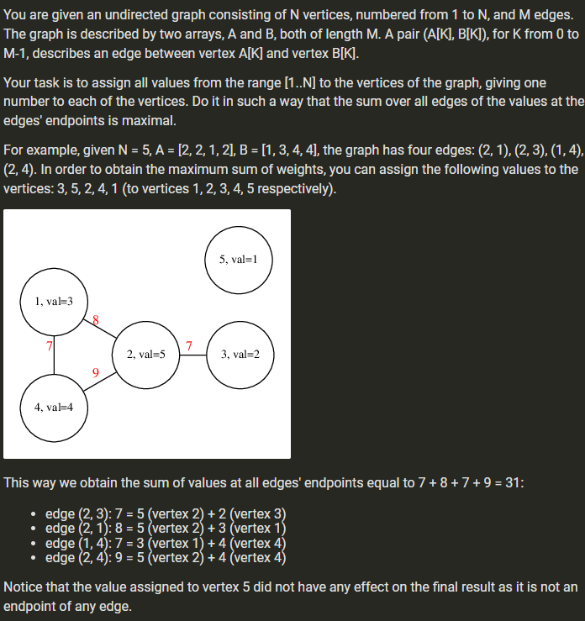

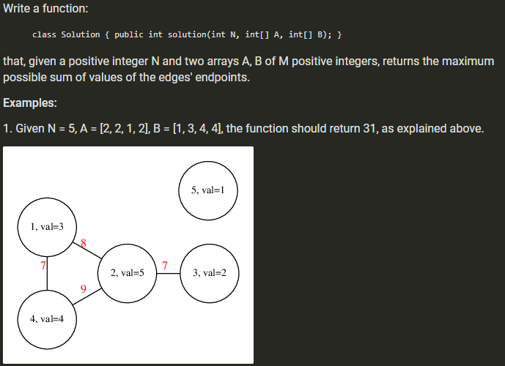

Task 3

